**Experiment No.7**

**Aim:**  Edit/compile/run a program to read a string and display the total number of uppercase and lowercase letters.

**Program A:**

str="Torna Fort, also known as Prachandagad, is a large fort located in Pune district, in the Indian state of Maharashtra. It is historically significant because it was the First Fort captured by CHHATRAPATI SHIVAJI MAHARAJ in 1646, at the age of 16."  
lower = 0  
upper = 0  
for i in str:  
 if (i.islower()):  
 lower+=1  
 elif(i.isupper()):  
 upper+=1  
print("The number of lowercase characters is: ",lower)  
print("The number of uppercase characters is: ",upper)

**Output:**

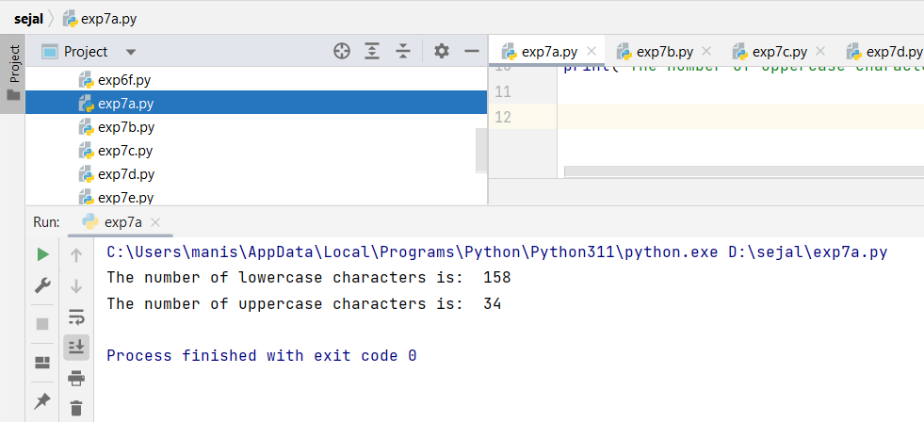

**Program B:**

def upperlower(string):

upper = 0  
 lower = 0  
 for i in range(len(string)):  
 if(ord(string[i]) >=97 and  
 ord(string[i]) <=122):  
 lower+=1  
  
 elif(ord(string[i]) >=65 and  
 ord(string[i]) <=90):  
 upper+=1  
 print('Lower case characters = %s' %lower, "\n"  
 'Upper case characters = %s' %upper)  
  
string = """Pearls of gleams in these Autumn Nights  
Adorn our lives else trite  
With Sparklers that motley skies  
As Soaring Spirits of powder wander  
Let us Thank the Heavenly might,  
In this Festive Season of Lights."""  
upperlower(string)

**Output:**

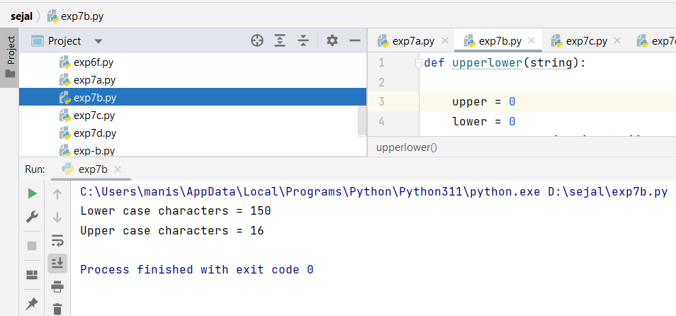

**Program C:**

s = "Gudhi Padwa is a Spring festival marking the start of the Traditional New Year primarily for Marathi and Konkani Hindus. It is celebrated in and around India at the start of Chaitra, the first month of the Lunisolar Hindu Calendar."  
l,u = 0,0  
for i in s:  
 if(i >= 'a' and i <= 'z'):  
 l=l+1  
 if(i>'A' and i<='Z'):  
 u=u+1  
print('Lower case characters: ',l)  
print('Upper case characters: ',u)

**Output:**

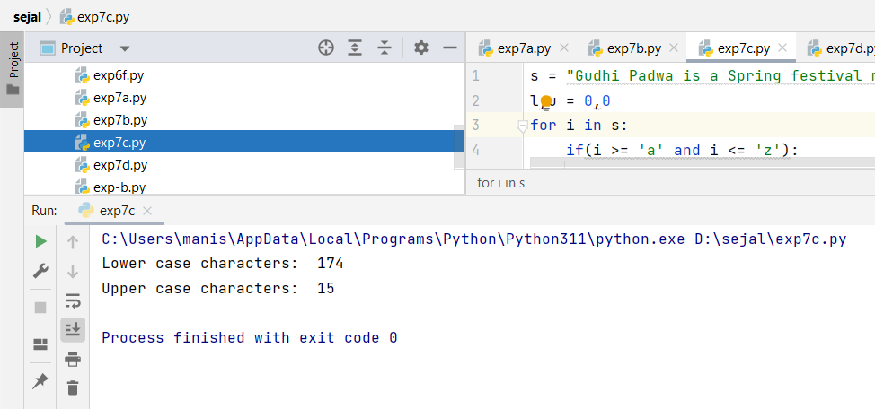

**Program D:**

string = """Friends are like the Sun and Moon,  
Always there to Light the Way,  
Through the Darkest Nights and Brightest Days,  
Their Love and Support never Sway."""  
upper = 0  
lower = 0  
up = "ABCDEFGHIJKLMNOPQRSTUVWXYZ"  
lo = "abcdefghijklmnopqrstuvwxyz"  
for i in string:  
 if i in up:  
 upper+=1  
 elif i in lo:  
 lower+=1  
print('Lower case characters = %s' %lower)  
print('Upper case characters = %s' %upper)

**Output:**

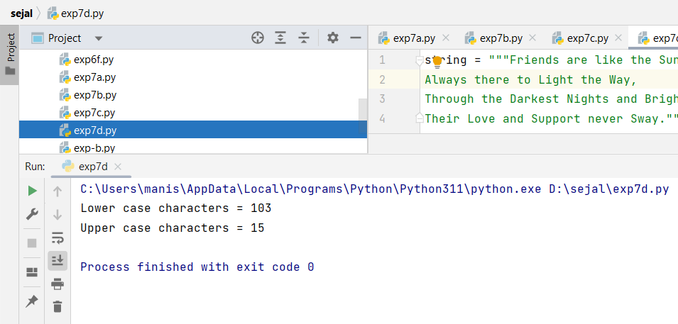

**Program E:**

string = input("Enter a string: ")  
  
uppercase = 0  
lowercase = 0  
  
for char in string:  
 if char.isupper():  
 uppercase += 1  
 elif char.islower():  
 lowercase += 1  
print("Total number of uppercase letters: ", uppercase)  
print("Total number of lowercase letters: ", lowercase)

**Output:**

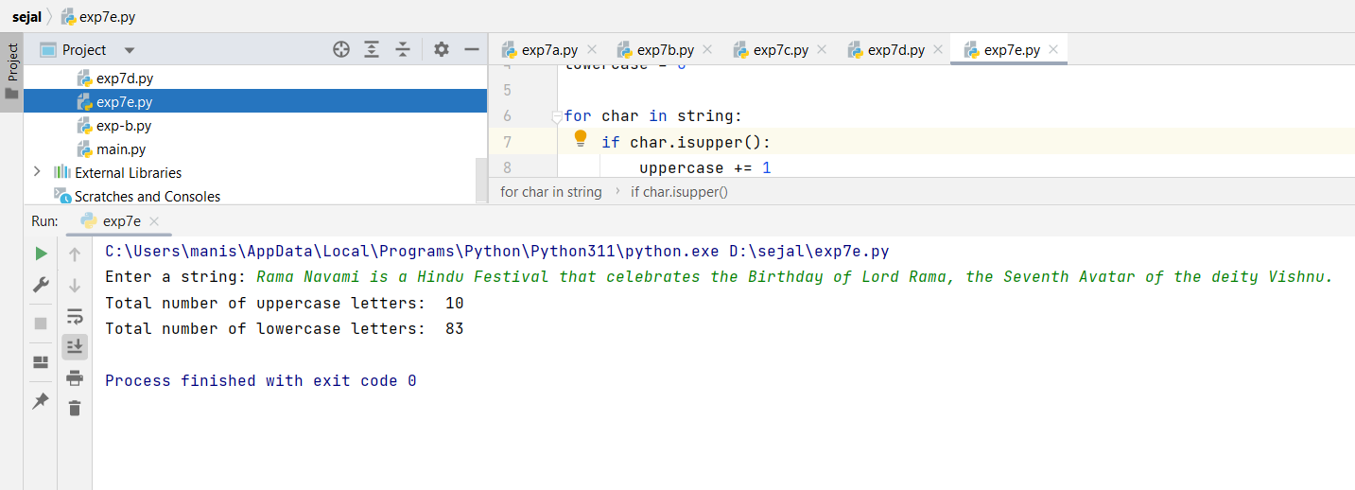

|  |  |  |  |
| --- | --- | --- | --- |
| **Practical Performance**  **(4)** | **Writeup & Oral**  **(4)** | **Attendance**  **(2)** | **Total**  **(10)** |
|  |  |  |  |